# Mathematical Model:

## Introduction

Before jumping into the mathematic model, some discussion of notation is needed. Due to the complexity of a system with 6 degrees of freedom, various methods of notation have been developed and are required in order to sufficiently describe the critical variables. Shown below is an example of the notation we have chosen:

$${}_{ }^{b}{{\dot{v}}_{CM|i}^{b}}$$

Here, the base variable is linear acceleration, or $\dot{v}$. As you can see, the variable also has two superscripts and one subscript to further delineate what we are describing. The top left superscript, b, tells us that the derivative taken was performed in the body frame of reference, while the top right superscript, $b$, tells us that the acceleration is given in terms of body frame vector components, and the subscript, $CM|i$, tells us that this variable is referencing the center of mass with respect to the inertial frame.

Another important aspect of the math model is the coordinate system that is used. The chosen model and conventions will become very important as you work through your model, so be sure to keep your decisions in mind and clearly documented. The coordinate system will vary whether you use a plus (“+”) or “X” configuration, which will be described below:

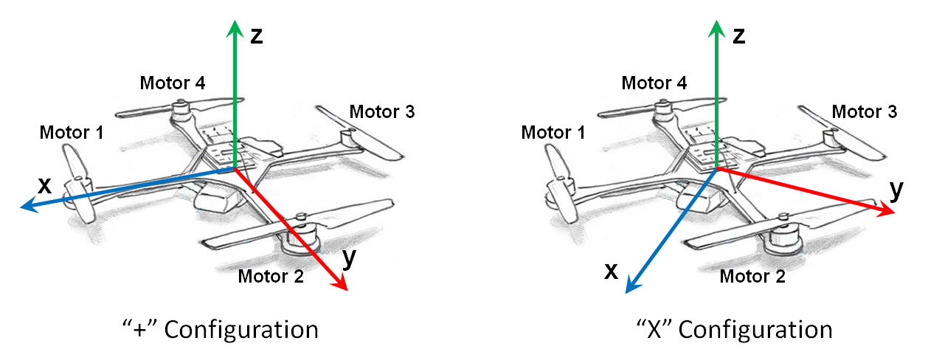

Figure . Plus Configuration Diagram

As seen in Fig. 1, the plus configuration we use is defined as having the X axis lie along the arm of motor 1 (which spins counter-clockwise from above, by our convention) with the Y axis set along the arm of motor 2 (spinning in the opposite direction of the adjacent motors) and the Z axis pointing upward. The value $d$ represents the distance from a given motor to the axis of rotation, and should be the same for every motor. This value will change if using an x configuration, which is defined as a rotation in the X-Y plane of 45 degrees in the positive yaw direction, which results in having the X axis lie between motor 1 and 2. In either configuration the x axis is assumed to be the positive forward direction for vehicle movement. For clarity, our rotation conventions are shown below in Figure 2.

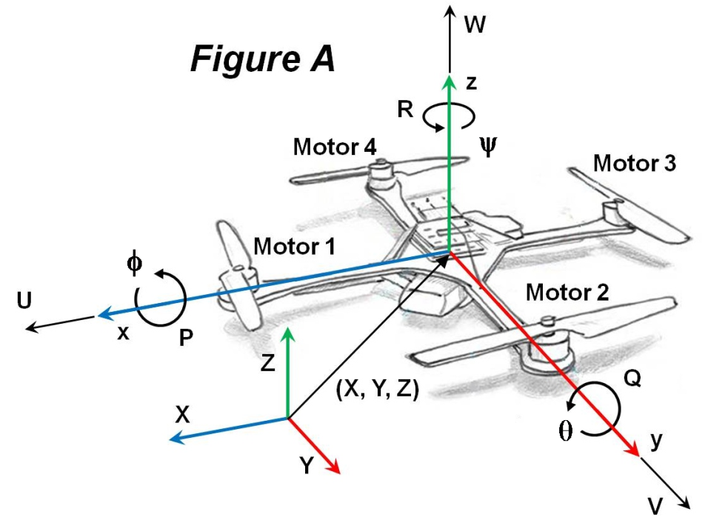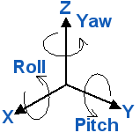

Figure . Axis labels and conventions (arrow direction positive (right-hand rotation))

## Mass Moment of Inertia Matrix

One element of the system of importance is the inertia matrix. The inertia matrix describes the quadcopters mass moment of inertia across the defined axes, and is important to the flight dynamics of the system. With some approximations, you can determine the mass moment of inertia across the X, Y, and Z axes in order to populate the required inertia matrix. This particular process is covered in more detail in the Mass Moment of Inertia documentation. Once determined using either the “+” or “X” configuration, the inertia matrix will appear as follows:

$J^{b}= \left[\begin{matrix}J_{xx} & 0 & 0 \\ 0 & J_{yy} & 0 \\ 0 & 0 & J_{zz}\end{matrix}\right]$**(Mass Moment of Inertia Matrix)**

Here, $J^{b}$ is the inertia of the quadcopter relative to the body frame with $J_{xx}$, $J_{yy}$, and $J_{zz}$ being the inertia of the quadcopter across each axis. Due to the symmetry of the system, the matrix is diagonal and **will be identical** for either a “+” or “X” configuration. The diagonal form of the matrix is convenient due to the need to invert the matrix for use in the angular velocity state equation.

## Thrust Coefficient

The motors' thrust is the driving force behind all quadcopter maneuvers and thus is integral to control design and simulation. The thrust, $T$, provided by a single motor/prop system can be calculated as follows:

$$T=C_{T}ρA_{r}r^{2}ϖ^{2}$$

Where $C_{T}$ is the thrust coefficient for a specific rotor, $ρ$ is the density of air, $A_{r}$ is the cross sectional area of the propeller's rotation, $r^{ }$ is the radius of the rotor, and $ϖ$ is the angular velocity of the rotor. For simple flight modeling a lumped parameter approach can be used to simplify the characterization process:

$T=c_{T}ϖ^{2}$**(Thrust Coefficient Relation)**

Here $c_{T}$ is the lumped parameter thrust coefficient that pertains to the individual motor/prop system. The thrust provided by the motor/prop provides a force perpendicular to the X-Y plane of the body frame in the positive Z direction.

## Torque Coefficient

In order to understand motor effect on yaw, the torque force of the motor/prop system must also be determined, and can be done in a similar fashion to that of the thrust tests. The related lumped parameter equation is shown below:

$Q=c_{Q}ϖ^{2}$**(Torque Coefficient Relation)**

In this case, $Q$ is the torque created by the motor and $c_{Q}$ is the torque coefficient for the motor/prop system. This torque provides a force that acts to yaw the system about the z-axis.

## Initial Matrix Construction

After performing a range of tests with each of the test stands, the provided data analysis programs can help you calculate these coefficients for characterizing your system. With this information we can create a matrix describing the thrusts and torques on the system like that shown below:

$\left[\begin{aligned}\begin{matrix}ΣT \\ τ_{ϕ}\end{matrix} \\ \begin{matrix}τ_{θ} \\ τ_{ψ}\end{matrix}\end{aligned}\right]= \left[\begin{matrix}c_{T} & c_{T} & c_{T} & c_{T} \\ 0 & {d_{+}c}_{T} & 0 & {-d_{+}c}_{T} \\ -{d_{+}c}_{T} & 0 & {d_{+}c}_{T} & 0 \\ {-c}_{Q} & c_{Q} & {-c}_{Q} & c_{Q}\end{matrix}\right]\left[\begin{matrix}ϖ_{1}^{2} \\ ϖ_{2}^{2} \\ ϖ_{3}^{2} \\ ϖ_{4}^{2}\end{matrix}\right]$**(“+” configuration)**

All of the present values have been explained thus far except for $d_{ }$, which is simply the distance between the motors and the respective axes of rotation, where $d_{+}$ is the arm length from quadcopter hub center to motor/prop.

If using an x configuration, $d_{x}$ can instead be found by $d_{+}sin(45)$, as that would be the value for the distance between the motor/prop and the body's axes of rotation. Thus, $c_{Q}$ experiences no change from this configuration adjustment, while the effect of $c_{T}$ will be distributed across all four motors for both pitch and roll.

$\left[\begin{aligned}\begin{matrix}ΣT \\ τ_{ϕ}\end{matrix} \\ \begin{matrix}τ_{θ} \\ τ_{ψ}\end{matrix}\end{aligned}\right]= \left[\begin{matrix}c_{T} & c_{T} & c_{T} & c_{T} \\ -{d_{x}c}_{T} & {d_{x}c}_{T} & {d_{x}c}_{T} & {-d_{x}c}_{T} \\ -{d_{x}c}_{T} & -{d_{x}c}_{T} & {d_{x}c}_{T} & {d_{x}c}_{T} \\ {-c}_{Q} & c_{Q} & {-c}_{Q} & c_{Q}\end{matrix}\right]\left[\begin{matrix}ϖ_{1}^{2} \\ ϖ_{2}^{2} \\ ϖ_{3}^{2} \\ ϖ_{4}^{2}\end{matrix}\right]$**(“X” configuration)**

## Throttle Command Relation

An important consideration here for control purposes is that the coefficients of thrust and torque are based on a relationship with RPM of the motors and not something directly determined by the control system (such as throttle command). Due to this, a linear regression is needed that will translate throttle command values (as percent throttle) to RPM values. The following regression was created for this purpose:

$$ϖ_{ss}=(Throttle\%)c_{R}+b$$

Here $ϖ_{ss}$ is the expected steady-state motor RPM, $Throttle\%$ is the throttle percentage command, $c_{R}$ is the throttle % to RPM conversion coefficient, and $b$ is the y-intercept of the linear regression relationship. The linear regression can be performed using the provided data analysis program, which allows your controller to use the proper coefficients as determined by your motor testing for maximum accuracy and realism.

## Gyroscopic Forces

There is one more set of forces to account for before we create our moment matrix, and those are the forces resulting from gyroscopic precession. Gyroscopic precession is a phenomenon that occurs when the axis of rotation of a rotating body is changed, and the results are typically non-intuitive to those unfamiliar with its effects. The gyroscopic forces resulting on the body are governed by the inertia of each motor’s rotating components ($J_{m}$), the rolling and pitching rates ( $P$ and $Q$), as well as the speed of each motor/prop system ($ϖ_{i}$). The gyroscopic torques created by the motors for pitch and roll action are shown below:

$$τ_{ϕ_{gyro}}=J_{m}Q\left(\frac{π}{30}\right)\left(ϖ_{1}-ϖ_{2}+ϖ_{3}-ϖ_{4}\right)$$

$$τ_{θ_{gyro}}=J_{m}P\left(\frac{π}{30}\right)(-ϖ_{1}+ϖ_{2}-ϖ_{3}+ϖ_{4})$$

The π/30 term corresponds to the transition from RPM to radians that must occur for the gyroscopic force to be calculated.

## Final Matrix Construction

With these motor/prop forces added in to the appropriate terms we can again organize the equations in matrix form for our simulation purposes. The resulting matrix will account for the mentioned aerodynamic, gyroscopic, and thrust moments created by the motor/prop systems on the quadcopter for a "+" configuration:

$M_{A,T}^{b}= \left[\begin{matrix}{d_{+}c}_{T}ϖ_{2}^{2}{-d_{+}c}_{T}ϖ_{4}^{2}+J_{m}Q(\frac{π}{30})\left(ϖ_{1}-ϖ_{2}+ϖ_{3}-ϖ_{4}\right) \\ -{d_{+}c}_{T}ϖ_{1}^{2}+{d_{+}c}_{T}ϖ_{3}^{2}+J_{m}P(\frac{π}{30})\left(-ϖ_{1}+ϖ_{2}-ϖ_{3}+ϖ_{4}\right) \\ {-c}_{Q}ϖ_{1}^{2}+c_{Q}ϖ_{2}^{2}{-c}_{Q}ϖ_{3}^{2}+c_{Q}ϖ_{4}^{2}\end{matrix}\right]$

Here, $M_{A,T}^{b}$ refers to the moments present in the body frame resulting from the aerodynamics, thrusts, and torques on the system. The quadcopter body also experiences forces that act on it from gravity and the lift of the rotors. The lift force can be expressed as follows:

$$F_{A,T}^{b}= \left[\begin{matrix}0 \\ 0 \\ c_{T}(ϖ_{1}^{2}+ϖ_{2}^{2}+ϖ_{3}^{2}+ϖ_{4}^{2})\end{matrix}\right]$$

$F_{A,T}^{b}$ refers to the forces acting in the body frame on the quadcopter due to aerodynamics and thrust (assumed oriented strictly in the positive z direction). It should be noted that while we say there are acting aerodynamic forces, it is assumed that the static thrust and torque tests capture the elements of aerodynamics that we are interested in. Additional effects (such as blade flapping, frame aerodynamic drag, etc.) could be added to the model after additional research and testing.

## State Equations

Now we move on to the state equations that define the dynamics model. The first we’ll discuss is the Angular Velocity State Equation.

${{}_{ }^{b}{\dot{ω}}}_{b|i}^{b}={(J^{b})}^{-1}\left[M_{A,T}^{b}- Ω_{b|i}^{b}J^{b}ω_{b|i}^{b}\right]=\left[\begin{matrix}\dot{P} \\ \dot{Q} \\ \dot{R}\end{matrix}\right]$**(Angular Velocity State Equation)**

This equation describes the change in roll ($P$), pitch ($Q$), and yaw ($R$) rates of the quadcopter by taking into account the inertia, angular velocity, and the moments applied by the motor/prop systems. ${{}_{ }^{b}{\dot{ω}}}_{b|i}^{b}$ is the angular acceleration across each axis in the body frame with respect to the inertial frame, and can also be written as.

$${{}_{ }^{b}{\dot{ω}}}_{b|i}^{b}= \left[\begin{matrix}\dot{P} \\ \dot{Q} \\ \dot{R}\end{matrix}\right]$$

Having already the inertia matrix and moment matrices, we move on to $Ω_{b|i}^{b}$ which is a cross-product matrix for rotational velocity. The form of this matrix is shown below:

$$Ω_{b|i}^{b}= \left[\begin{matrix}0 & -R & Q \\ R & 0 & -P \\ -Q & P & 0\end{matrix}\right]$$

Here, P, Q, and R are again the rotation rates about the X, Y, and Z axis, respectively. The $ω_{b|i}^{b}$ term is the rotational velocity of the quadcopter body within the body frame and is defined directly by P, Q, and R.

$$ω_{b|i}^{b}= \left[\begin{matrix}P \\ Q \\ R\end{matrix}\right]$$

The next state equation defined is the Euler Kinematic Equation, which allows us to determine the rate of change of the Euler angles in the inertial frame.

$$\dot{Φ}= H\left(Φ\right)ω_{b|i}^{b}=\left[\begin{matrix}\dot{ϕ} \\ \dot{θ} \\ \dot{ψ}\end{matrix}\right]$$

Before discussing this equation we’ll discuss rotation matrices. According to the aerospace rotation sequence, the rotation of an aircraft is described as a rotation about the z-axis (yaw) then a rotation about the y-axis (pitch) followed by a rotation about the x-axis (roll). Each rotation is made based on a right-handed system and in a single plane.

Using these three rotations a composite rotation matrix can be created which can transform the motion of the aircraft from the body frame to a new reference frame. The resulting rotation matrix transforms rotations from the body frame with respect to the inertial frame and can be found using matrix multiplication. Below s, c, and t represent sine, cosine, and tangent functions respectively.

$$u^{b}= \left[\begin{matrix}1 & 0 & 0 \\ 0 & c(ϕ) & s(ϕ) \\ 0 & -s(ϕ) & c(ϕ)\end{matrix}\right]\left[\begin{matrix}c(θ) & 0 & -s(θ) \\ 0 & 1 & 0 \\ s(θ) & 0 & c(θ)\end{matrix}\right]\left[\begin{matrix}c(ψ) & s(ψ) & 0 \\ -s(ψ) & c(ψ) & 0 \\ 0 & 0 & 1\end{matrix}\right]u^{i}$$

Following through with the matrix multiplication yields the rotation matrix from the inertial to the body frame using the aerospace rotation sequence:

$$C_{b|i}= \left[\begin{matrix}c\left(θ\right)c(ψ) & c\left(θ\right)s(ψ) & -s(θ) \\ (-c\left(ϕ\right)s\left(ψ\right)+s\left(ϕ\right)s\left(θ\right)c\left(ψ\right)) & (c\left(ϕ\right)c\left(ψ\right)+ s\left(ϕ\right)s\left(θ\right)s\left(ψ\right)) & s\left(ϕ\right)c(θ) \\ (s\left(ϕ\right)s\left(ψ\right)+ c\left(ϕ\right)s\left(θ\right)c\left(ψ\right)) & (-s\left(ϕ\right)c\left(ψ\right)+ c\left(ϕ\right)s\left(θ\right)s\left(ψ\right)) & c\left(ϕ\right)c(θ)\end{matrix}\right]$$

**(ZYX Sequence Rotation Matrix)**

This rotation matrix is of particular importance in solving the velocity and position state equations. A complete discussion of rotation matrices is beyond the scope of this document.

Using sequential rotation matrices, the angular velocity of the aircraft in the body frame can be related to the changes in angle rotation as shown below, where the C matrices of $ϕ and θ$ are those from u*b*.

Performing matrix multiplication and addition and taking the derivative the Euler Kinematic Equation can be found (details not given here):

$\dot{Φ}= \left[\begin{matrix}\dot{ϕ} \\ \dot{θ} \\ \dot{ψ}\end{matrix}\right]= \left[\begin{matrix}1 & t\left(θ\right)s(ϕ) & t\left(θ\right)c(ϕ) \\ 0 & c(ϕ) & -s(ϕ) \\ 0 & s\left(ϕ\right)/c(θ) & c\left(ϕ\right)/c(θ)\end{matrix}\right]\left[\begin{matrix}P \\ Q \\ R\end{matrix}\right]=H(Φ)ω_{b|i}^{b}$**(Euler Kinematic Equation)**

While this approach is effective, there is one very important drawback; a singularity occurs when *θ* is equal to ± $90°$. Due to this, the accuracy and numerical stability of a simulation can be compromised if the aircraft's pitch approaches or reaches ±90°. Considering the modest control design intentions of this simulation, this will not be an issue for most users. However, several approaches to avoiding this problem exist, including using quaternions for the simulation, and thus motivated users may choose to modify our simulation to utilize this or another approach to removing this singularity.

The next state equation we discuss is the Velocity State Equation, which describes the acceleration of the center of mass of the rigid body quadcopter model based on the forces and accelerations acting on the body.

${}_{ }^{b}{{\dot{v}}_{CM|i}^{b}}=\left(\frac{1}{m}\right)F_{A,T}^{b}{+g}^{b}- Ω_{b|i}^{b}ω_{CM|i}^{b}=\left[\begin{matrix}\dot{U} \\ \dot{V} \\ \dot{W}\end{matrix}\right]$**(Velocity State Equation)**

Here, ${}_{ }^{b}{{\dot{v}}_{CM|i}^{b}}$ is the linear acceleration of the center of mass in the body frame with respect to the inertial frame. The variable $m$ is the total mass of the quadcopter, while $g^{b}$ is the acceleration of gravity translated to act in the body frame by the rotation matrix $C_{b|i}$.

$$g^{b}= C_{b|i}g^{i}$$

Using this equations you can find the linear acceleration of the quadcopter in the X, Y, and Z directions of the body frame.

Finally, the last state equation to be covered is the Position State Equation, which describes the linear velocity of the center of mass of the quadcopter in the inertial frame.

${}_{ }^{i}{{\dot{P}}_{CM|i}^{i}}=C_{i|b}^{ }v_{CM|i}^{b}=\left[\begin{matrix}\dot{X} \\ \dot{Y} \\ \dot{Z}\end{matrix}\right]$**(Position State Equation)**

Here, $v_{CM|i}^{b}$ is simply the velocity of the quadcopter in the body frame that is rotated into the inertial frame using the transpose of $C_{b|i}$, which is $C_{i|b}^{ }$. This state equation allows us to determine the velocity of the quadcopter in the X, Y, and Z directions of the inertial frame.